STUDIO WEAR ORDER FORM

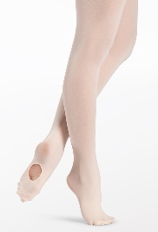 BALLET TIGHTS – CHILDREN’S / CONVERTIBLE / BALLET PINK $20

SIZE ___ XSC ___ SC ___IC ___MC ___LC

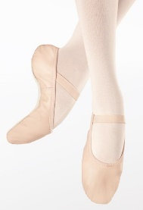 BALLET SHOES – CHILDREN’S/BALLET PINK $30

STREET SHOE SIZE ______ SIZED IN STUDIO (BY TEACHER) ______

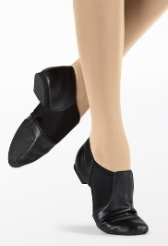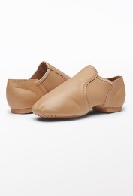 JAZZ SHOES – CHILDREN’S $45

COLOUR ____BLACK ___CARAMEL ___HAZELNUT

STREET SHOE SIZE ______ SIZED IN STUDIO (BY TEACHER) _____
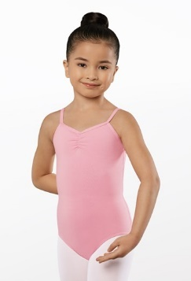 COTTON PINK FRONT LEOTARD – CHILDREN’S $30

COLOUR ____ LAVENDER ____PINK

SELECT SIZE ____XXSC ____XSC ____SC
____IC ____MC ____LC
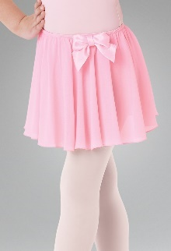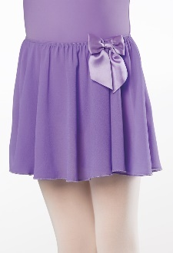 BALLET SKIRT– CHILDREN’S $25

COLOUR ____ VIOLET ____PINK

SELECT SIZE ____ XXSC ____XSC ____SC
____IC ____MC ____LC ____XLC
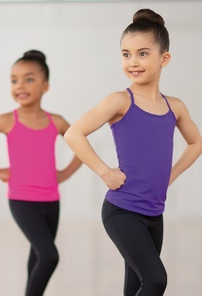 RACERBACK CAMISOLE TANK TOP – CHILDREN’S $40 ADULTS $45

SELECT COLOUR ____ PINK ____PURPLE ____BLACK

SELECT SIZE ____XXSC ____XSC ____SC
____IC ____MC ____LC
____XSA ____SA ____MA
____LA ____XLA
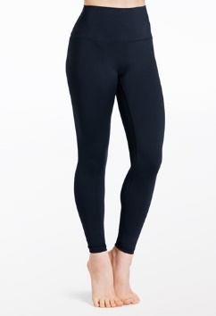 LEGGINGS – BLACK CHILDREN’S $60
ADULTS $65

SELECT SIZE ____SC ____IC ____LC
____XSA ____SA ____MA
____LA ____XLA

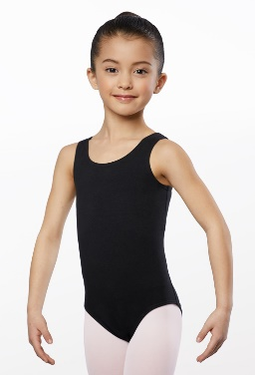 COTTON TANK LEOTARD – BLACK CHILDREN’S $30
ADULT’S $35

SELECT SIZE ____XXSC ____XSC ____SC
____IC ____MC ____LC
____XSA ____SA ____MA
____LA ____XLA

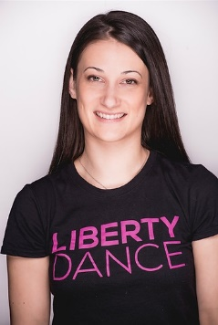 LIBERTY DANCE T-SHIRT – BLACK & PINK CHILDREN’S $40
ADULTS $45

SELECT SIZE ____XXSC ____XSC ____SC
____IC ____MC ____LC
____XSA ____SA ____MA
____LA ____XLA

DANCER: __________________________________________________________________________________

PAYMENT TOTAL: $___________________

PAYMENT METHOD: _____ CASH _____E-TRANSFER _____CREDIT CARD

Name on credit card: _______________________________________________________________
Address/Postal Code: ______________________________________________________________
Credit Card #: _____________________________________________________________________
Expiry: _______________
Security Code (back of card): __________

SEND ORDER TO ADMIN@LIBERTYDANCE.ORG

ALTERNATIVELY, YOU CAN ORDER STRAIGHT FROM THE BSPORT APP USING YOUR EMAIL LOGIN

YOU WILL BE NOTIFIED ONCE YOUR ORDER IS READY FOR PICK-UP

THANK YOU!

