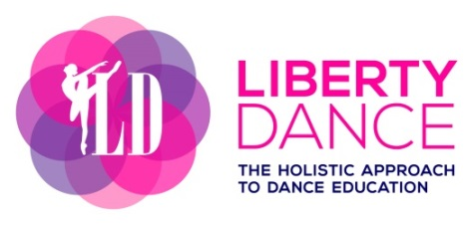
Uniform Policies

Dance Style: | Clothing: | Shoes: | Hair:
Ballet:  Children & Youth  Adult | Bodysuit  Skirt (optional)  Ballet tights  Athletic or ballet apparel | Ballet shoes in canvas or leather (split or full sole)  Ballet shoes or similar | Bun with secured pins  Optional
Jazz: | Bodysuit or tank top  Leggings | Jazz shoes | Bun or ponytail – no loose hair
Acro: | Bodysuit or tank top  Leggings | Bare feet | Bun or ponytail – no loose hair
Hip Hop: | Loose fitting clothing | Running shoes (clean) | Ponytail
Parent & Tot: | Comfortable attire or ballet/jazz apparel | Bare feet, ballet or jazz shoes | Optional ponytail

